14.58: The fraction f of the volume that floats above the fluid is 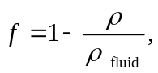 whereis the average density of the hydrometer (see Problem 14.23 or Problem 14.55), which can be expressed as 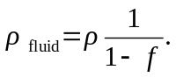 Thus, if two fluids are observed to have floating fraction 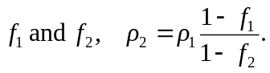 In this form, it’s clear that a larger 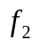 corresponds to a larger density; more of the stem is above the fluid. Using gives 